3GPP TSG-RAN WG4 Meeting#119 R4-2606888
Dalian, CN, May 18 - 22, 2026
Agenda item: 8.10.6
Source: ZTE Corporation, Sanechips
Title: Discussion on testing for 6G sensing
Document for: Approval
- Introduction
In RAN#108 meeting, a new SID on Study on 6G Radio [1] was approved. In this contribution, we would like to share some further understandings on 6GR ISAC study.
- Sensing – Studies to be based on use cases and associated requirements, as defined in [TR38.914]
- PHY functions and procedures for sensing technology (e.g., waveform. reference signals, measurement feedback, etc…) [RAN1, RAN4]
- Evaluate sensing performance and if necessary, extend channel modelling, for the selected use cases [RAN1]
- Aspects of integration with communication services [RAN1]
- higher layer procedures and protocol aspects [RAN2]
- RAN4 aspects of sensing including RF, coexistence, and testability in coordination with other WGs [RAN4]
Note: RAN1 identify detailed requirements, if triggered by TSG RAN
RAN4#116bis:
Agreement:
Before April 2026, the agenda for sensing will be kept. RAN4 discussion will primarily focus on the following aspect
- Sensing related regulatory status and requirement survey
- Potential architecture consideration based on the RAN plenary use case study
- views sharing on the potential RAN4 scope based on the identified use cases out of RAN plenary study
- Identify less RAN1 design dependent RAN4 aspects if any

- Discussion

2.1. Testing impacts for TRP mono-static sensing mode
For 6G sensing BS, since its conformance testing is expected to be different from the legacy 5G conformance testing due to the moving testing target. In the following Figure 2.1-1 and Figure 2.1-2, we provide the initial consideration for test setup in both OTA chamber and conducted method. In the OTA chamber, the moving passive objective should be emulated e.g. moving along the track.
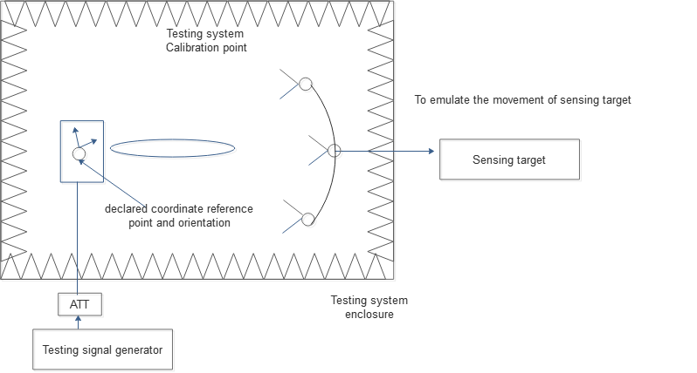
Figure 2.1-1.Illustration of OTA conformance testing for ISAC- monostatic BS
As shown in Figure 2.1-2, the conducted testing is also possible by emulating the passive objective’s movement similar as satellite LEO channel. In the following figure 2.1.-2, the different configuration in the relevant channel model could be set to emulate the movement of passive objective (e.g. doppler shift to emulate the movement, phase/amplitude difference among the sub-array to emulate the specific arrival angle and different pathloss to emulate the the distance between passive objective and sensing BS).
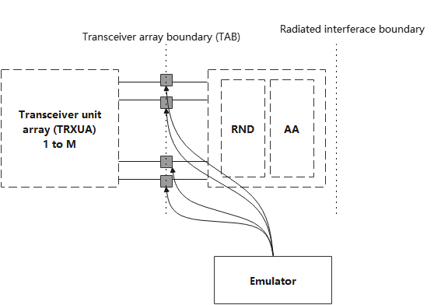
Figure 2.1-2..Illustration of conducted conformance testing for ISAC- monostatic BS
Proposal 1: For the 6G TRP monostatic conformance testing, propose to consider both OTA and conducted testing method.

2.2. Testing impacts for other sensing mode
For testing method for other sensing mode, the emulation of passive objective’s movement could be similar as TRP-monostatic solution, however whether other assistant information from TRP or UE should be further discussed and how the received raw signal is processed and reported should be further discussed in the coming RAN4 meeting.
Proposal 2: For the sensing mode other than TRP monostatic conformance testing, propose to further discuss whether the assistant information from TRP or UE is needed and how the received raw signal is processed and reported.

2.3. Channel modelling for 6G sensing
In addition, during the Rel-19 NR ISAC channel modelling study as captured in TR 38.901 including all sensing mode and relevant use cases, from RAN4 testability perspective, whether these complicated channel for different sensing mode and use case can be emulated in the OTA chamber or channel emulator in the conformance testing.
Proposal 3: Propose to discuss and study how to establish the channel modelling as captured in TR 38.901 and whether any simplifications are potentially needed for the practical testing setup.
- Conclusions
In this contribution, we shared some initial views on the 6GR sensing study and proposals are made as follows:
Proposal 1: For the 6G TRP monostatic conformance testing, propose to consider both OTA and conducted testing method.
Proposal 2: For the sensing mode other than TRP monostatic conformance testing, propose to further discuss whether the assistant information from TRP or UE is needed and how the received raw signal is processed and reported.
Proposal 3: Propose to discuss and study how to establish the channel modelling as captured in TR 38.901 and whether any simplifications are potentially needed for the practical testing setup.
- References
- RP-251881,New SID: Study on 6G Radio, Approved.
- RP-251742, Study on 6G scenarios and requirements - ISAC, ZTE,
- R1-2506131,Discussion on 5G-A ISAC evaluation,ZTE, Noted.
- RP-252024 RAN KPIs for IMT-2030
- R4-2602286 WF on 6G sensing, approved.
- R1-2505006, channel modelling for NR ISAC, approved.

